**Laboratory work 4**

### **Create your own layout with CSS Grid**

Test out the new concepts you've learned in the Lecture 3 by creating a calendar with CSS Grid.  A calendar is a classic way to arrange content using rows and columns.

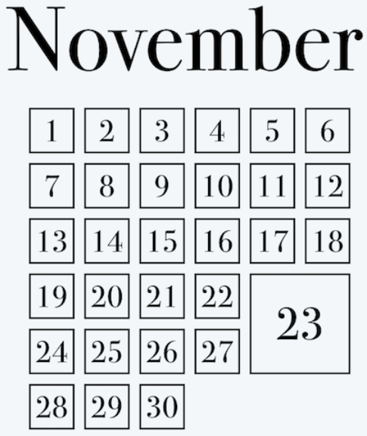

Choose any month you like, as well as the background color, font, and font color. The only rules are as follows:

* You must have all date elements within a grid using CSS Grid.
* You must have one of the dates bigger than the others (a holiday, for example). This element will have a custom measurement using CSS Grid.
* You must have a heading for the month that is not part of the grid.

This link provide you with the theoretical knowledge to solve this task:

<https://openclassrooms.com/en/courses/5295881-create-web-page-layouts-with-css/5369951-set-columns-depending-on-screen-size>

1. **Working with Flexbox**

Learn in more detail how to work with Flexbox:

1. [What is Flexbox?](https://openclassrooms.com/en/courses/5295881-create-web-page-layouts-with-css/5414886-what-is-flexbox)
2. [Set flex direction and wrapping](https://openclassrooms.com/en/courses/5295881-create-web-page-layouts-with-css/5414941-set-flex-direction-and-wrapping)
3. [Align items and justify content](https://openclassrooms.com/en/courses/5295881-create-web-page-layouts-with-css/5415181-align-items-and-justify-content)
4. [Align multiple lines of content](https://openclassrooms.com/en/courses/5295881-create-web-page-layouts-with-css/5415606-align-multiple-lines-of-content)
5. [Adjust element dimensions](https://openclassrooms.com/en/courses/5295881-create-web-page-layouts-with-css/5415656-adjust-element-dimensions)
6. [Reorder elements](https://openclassrooms.com/en/courses/5295881-create-web-page-layouts-with-css/5419976-reorder-elements)